**EcoWaterZinc and ColourTune projects implemented under the CORNET Initiative** 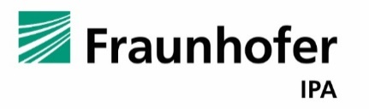

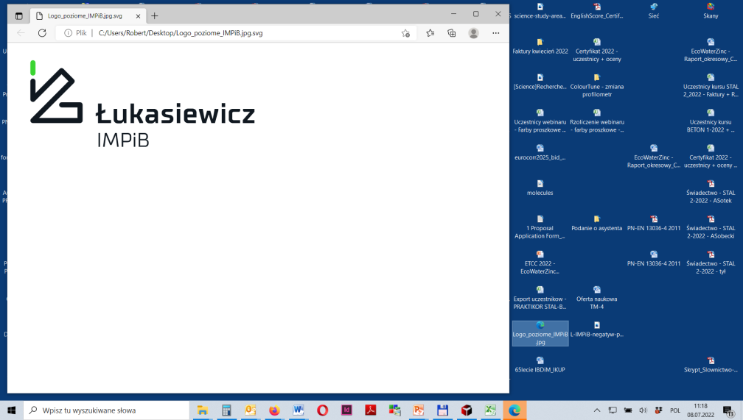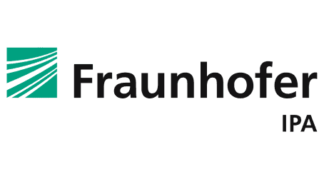

#### The Polish Corrosion Society [PSK] is implementing further projects from the CORNET Initiative group of projects. These are: a project with the acronym EcoWaterZinc titled “Waterbased, environmentally friendly Zinc rich primer systems” and the ColourTune project titled "Tuning the color of topcoats - method for selection of pigments and safeguarding color stability". The projects are performed by: Road and Bridge Research Institute [IBDiM], Lukasiewicz Research Network - Institute of Polymer Materials and Dyes Engineering [SBŁ-IMPiB] in cooperation with German Partners: Forschungsgesellschaft für Pigmente und Lacke e.V. [FPL] and Fraunhofer Institute for Manufacturing Engineering and Automation [IPA].

#### The EcoWaterZinc and ColourTune projects are funded from the state budget by the National Center for Research and Development under the CORNET Initiative program.

 

**EcoWaterZinc**

The aim of the project is to develop effective zinc primers with a reduced amount of zinc pigments for ecological and economic reasons. For this purpose, zinc pigments of various shapes were used in the formulations being developed: zinc dust and zinc flakes, untreated and surface treated with silanes, wet, with monofunctional alcohol, and dry. Proper surface treatment prevents the evolution of hydrogen, which is a common problem when formulating this type of water-based primers. The developed paints contain 35 wt.% zinc pigments.

Selected formulation variants of paints (both alone and in coating systems) were tested for physical and mechanical properties (hardness, impact resistance, flexibility, drawability and adhesion to the substrate) and anti-corrosion properties (resistance to neutral salt mist and moisture resistance). The anti-corrosion properties of the coatings were also tested by electrochemical impedance spectroscopy (EIS) when the samples were immersed in 3% NaCl solution and after exposure in a salt chamber. The tests were carried out in comparison with a commercially available water-based zinc-rich epoxy paint and with a paint containing 60 wt.% zinc, they were also compared with traditional zinc-rich solvent primers.

The expected corrosion resistance at a reduced zinc content (35 wt.%) is obtained when the zinc pigments have different shapes (flakes and grains). The addition of zinc phosphate delays the dissolution of zinc and extends the period of cathodic protection, and therefore further increases the anti-corrosion properties. The wet surface treatment of zinc pigments also has a positive effect on the improvement of the anti-corrosion properties of the coatings.

The developed water-based paints are characterized by better formability, bending resistance and impact resistance than most solvent-based paints and, at the same time, lower hardness. Such behavior of coatings with a reduced content of zinc pigments results from the value of SOP much lower than that of KSOP.

Photo 1 shows the scanning microscope-obtained distribution of zinc pigments in examples of zinc-reduced primers

a/ b/ c/

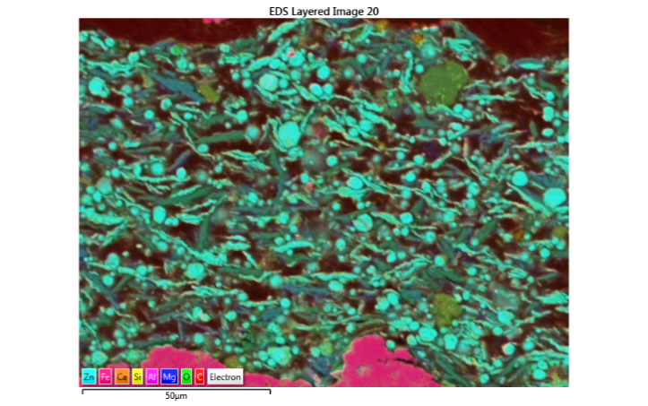

#### Fot. 1. a/ Zinc flakes/wet organic treatment and Zinc dust; b/mixture of Zinc flakes and Zinc Dust; c/ Zinc dust with dry organic treatment

The research shows that it is possible to obtain aqueous anti-corrosion primers containing less zinc than traditional high-zinc primers, but equal to them in terms of protective properties.

**ColourTune**

The influence of the environment causes changes in the colors of topcoats. Requirements for color fastness of powder coatings are included in the Qualicoat, Qualisteel, AAMA and GSB standards, but no recommendations have yet been made for liquid paints.

The main objective of the project is to see if, as a result of aging tests of coatings under cyclically varying conditions involving changes in temperature, humidity and UV radiation, it is possible to determine with high probability how surface coatings should be modified to improve their resistance to weathering, with particular emphasis on optical properties (gloss retention, color). The test scheme is shown below. The coatings are also being tested under natural conditions at a field station in Stuttgart.

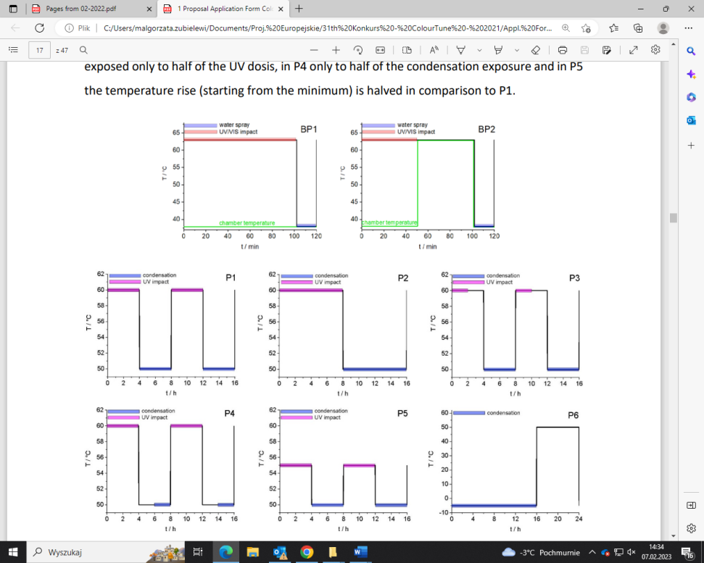Requirements for color fastness of powder coatings are included in the Qualicoat, Qualisteel, AAMA and GSB standards, but no recommendations have yet been made for liquid paints.

The main goal of the project is to check whether it is possible to determine with high probability how topcoats should be modified in order to improve their resistance to weather conditions, with particular emphasis on optical properties (gloss retention, color).

Coatings will be tested in cyclically changing conditions, including changes in temperature, humidity and UV radiation, The research scheme is shown below. The coatings will be also tested under natural conditions at the Stuttgart field station.

#### The results of tests can be used to determine how long the aging tests should last and according to what cycle, to obtain a sufficiently large variation of results, and thus the information needed to guide the optimization of formulations , as well as which of the factors (UV, water or fluctuations in temperature and humidity) has the greatest impact on the decorative (and protective) properties of the coatings.

#### The results of the project will be used both to verify the laboratory test methods simulating weather conditions and to determine the possibility of improving the properties of topcoats in order to obtain the best color stability.